Agricultural Analysis Of Machine Learning Algorithms for Crop Prediction

Laksh Savaliya

*Department of Computer Engineering*  
*Devang Patel Institute of Advance Technology & Research (DEPSTAR),*

*Faculty of Technology & Engineering (FTE), Charotar University of Science & Technology (CHARUSAT),*

Changa 388421, India  
[lakshsavaliya17@gmail.com](mailto:kansagarareeva@gmail.com)

22dce107@charusat.edu.in

Premal Patel

*Department of Computer Engineering*  
*Devang Patel Institute of Advance Technology & Research (DEPSTAR),*

*Faculty of Technology & Engineering (FTE), Charotar University of Science & Technology (CHARUSAT),*

Changa 388421, India

[premalj_patel@yahoo.com](mailto:premalj_patel@yahoo.com)

Manav Sapovadiya *Department of Computer Engineering*  
*Devang Patel Institute of Advance Technology & Research (DEPSTAR),*

*Faculty of Technology & Engineering (FTE), Charotar University of Science & Technology (CHARUSAT),*

Changa 388421, India  
sapovadiyamanav9@gmail.com

22dce106@charusat.edu.in

Milind Shah*  
Assistant Professor

*Department of Computer Engineering  
Sardar Vallabhbhai Patel Institute of Technology (S.V.I.T),*Vasad, Gujarat, India  
[milindshahcomputer@gmail.com](mailto:milindshahcomputer@gmail.com%20%20%20%20%20%20) Dweepna Garg

*Department of Computer Engineering*  
*Devang Patel Institute of Advance Technology & Research (DEPSTAR),*

*Faculty of Technology & Engineering (FTE), Charotar University of Science & Technology (CHARUSAT),*

Changa 388421, India

[dweeps1989@gmail.com](mailto:dweeps1989@gmail.com)

*Abstract*—Farming holds great importance in India, a country that depends significantly on agriculture. According on the 2022-23 census, the proportion of Gross Value Added (GVA) contributed by agricultural and associated sectors to the overall Indian economy is 18.3%.When choosing which crop to cultivate and farm, it is important to examine several factors such as production rate, environmental conditions, soil type, temperature and pH .The project addresses the critical need for accessible information in agriculture, revolutionizing farmers decision-making with personalized crop management recommendations. Also ,The proposed solution to this problem involves the use of an ensemble model with a majority voting technique. The model utilizes K-Mean, Random Forest, Linear Regression, and Support Vector Machine as learners to recommend a crop based on site-specific parameters. This approach ensures high accuracy and efficiency in the crop recommendation system. The hybrid method combining K-means and random Forest achieved the best accuracy of 99.77% compared to other algorithms. Hence, our proposed approach will assist farmers in selecting the appropriate seed and identifying plants based on soil specifications, thereby enhancing crop yield. Maximize efficiency and generate financial gain from this approach. Python is used for programming, and the libraries Pandas, NumPy, Scikit-Learn, Matplotlib, and Seaborn are employed.

Keywords—Agriculture, Analysis, Crop Prediction, Machine Learning, Random Forest, K-mean, SVM .

# Introduction

India's agriculture serves as the fundamental support of the country, supplying not only sustenance and shelter but also a range of industries including textiles, development, and food processing. Approximately half of the population in India depends on agriculture as their primary source of income. [16].Forecasting yields for crops is an essential challenge in the field of agriculture. It's had significant consequences on a global, regional, and local scale. Predictions of yields are affected by various elements, such as soil conditions, climatic patterns, environmental factors, and crop characteristics. Decision support models often utilize crop feature extraction. Precision agriculture encompasses the use of sensing technology, management information systems, variable rates, and adaptive strategies to address variations within the agricultural system. Precision agriculture has two benefits: enhanced productivity in agriculture and better crop quality. In addition, it helps decrease the environmental impact. A crop yield simulation, in addition to analyzing nutrient and water deficits, pests, and illnesses, may utilize machine learning algorithms to estimate crop yield and categorize the crop[13]. Agriculture has an essential position in India's economy and workforce.

The field of agriculture has undergone significant transformations in recent years due to the process of globalization. They aim for calmness by adhering strictly to conventional farming practices and standards, even though the growth of crops is heavily affected by existing weather and soil conditions. The primary aim of the proposed research is to develop a recommendation system that can accurately recommend appropriate crops for production. The system also aims to improve crop yield by minimizing the occurrence of improper crop choices [10] . However, when agricultural producers have precise knowledge of the crop, it minimizes losses.

The process of making important decisions related to the fundamental aspects of crop-related applications. Several modern algorithms rely on earlier Machine Learning models. The primary rationale for employing machine learning in agriculture is to enhance yields in agriculture. For the system to adapt to the pattern, multiple classifier methods such as Random Forest, Naive Bayes, and Logistic Regression utilize physical factors such as temperature, rainfall, pH (Potential of Hydrogen), and so on. After thorough examination, we have concluded that the K Mean yields the most accurate outcome of the machine learning algorithms mentioned. The technique uses previous data collection to make forecasts about crop predictions[15].

Although it is one of the oldest countries that still engage in forecasting, the agricultural sector has experienced substantial growth in recent years as a result of worldwide. Several things contribute to have impacted the viability of agriculture in India. Various ways have been devised to restore physical fitness, one of which is precise agriculture[12]. The implementation of advanced methods can aid farmers in selecting the most suitable crop for production. Increasing crop yield ultimately strengthens the country's position in all domains. The forecast will assist the relevant industries in strategizing for the benefit of their firm. Precise fertilization Predictions can assist farmers in determining which crops to cultivate and the optimal timing for their utilization. This may help affiliated industries in analysing the structure of their firm[7].

# Literature Survey

First, In [3] Janmejay Pant et al, The objective is to explain several regression techniques for analysing yield data sets. A comparison analysis was conducted on several algorithms. This work presents a crop prediction model utilizing the k-means algorithm. The productivity of crops is predicated upon the fertility of the soil. Soil fertility is influenced by various factors such as air, water, organic matter, and nutrients. In recent times, the fertility of soil has been consistently decreasing due to several causes such as the usage of fertilizers, herbicides, insecticides, and farming practices. Machine Learning models are utilized in agricultural research to forecast crop productivity. A comparison is conducted among the Gradient Boosting Regressor, Random Forest Regressor, Support Vector Machine (SVM), and Decision Tree Regressor

In [4] Kasi Lohitha Reddy et al, The objective of the present work is to forecast crop yield and extract and synthesize the CYP features for crop recommendation. Furthermore, several approaches have been developed to analyse agricultural output prediction by employing machine learning techniques such as gradient boosting, decision tree, and random forest algorithms. These algorithms are used to make precise forecasts and provide recommendations on the optimal crops to cultivate. The expected RFR value is 89.73%, while the crop yield prediction model forecasts 89.18%. The relative standard deviation (RSD) for DTR is almost 1% lower (6.41%) compared to RFR (5.83%), suggesting that RFR is the more favorable choice.Furthermore, both RFC and GB had a remarkable accuracy rate of 98%.In future endeavors to enhance crop production prediction, it would be beneficial to analyze and include a crop-specific disease dataset.

In [5] N. V Suresh Krishna et al, This project assists novice farmers by utilizing machine learning algorithms to provide guidance on selecting the appropriate crops for sowing based on soil conditions. The seeds are gathered according to the soil characteristics, including nitrogen, phosphorus, potassium, temperature, and humidity. A random forest is an ensemble of decision trees, where each tree's branches are determined by values from a randomly chosen subset that exhibits a similar pattern to the other trees in the forest. In order to enhance the dependability of the outcomes, Random Forest utilized the bagging technique to train the data. The suggested method is an online application that uses predictive algorithms to determine the names of crops and accurately calculate their corresponding yields. On the other hand, the yield of crops is mostly governed by the size of the cultivated area and the level of production. In future endeavors, it is beneficial to integrate soil characteristics into the system, as soil information is an essential factor in determining crop choices. Optimal circumstances are necessary for cultivating crops. Weather data can be utilized to assess the need for additional water. This scientific endeavor can be elevated to a higher level by ensuring its accessibility to the entire nation.

In [6] Saksham Mishra et al, The suggested approach integrates artificial intelligence (AI) and machine learning (ML) methodologies with specialized knowledge in order to offer farmers precise, timely, and customized suggestions for appropriate crops. This is achieved by considering parameters such as soil type, climatic circumstances, and market demand. This system seeks to transform traditional agricultural practices in India by utilizing data-driven insights to optimize crop management. The ultimate goal is to enhance production, profitability, and the sustainability of farming. The Random Forest Algorithm is chosen due to its numerous advantages and lower susceptibility to overfitting compared to Decision Tree and other algorithms. Additionally, it offers significant information regarding the significance of features. Upon implementing the four algorithms on our dataset. Random Forest, SVM, and Decision Tree can be observed. All generate results with greater precision than the combined use of the other three techniques.

In [7] M. Kandan et al, The primary objective of the proposed project is to gather agricultural and climatic data and conduct an analysis in order to forecast crop yields. The proposed research implements the random forest algorithm to address agricultural issues by providing farmers with recommendations on suitable crops and their expected yields. This is achieved through the analysis of climatic and agricultural characteristics, such as the geographical location, season, and rainfall. The accuracy of our proposed method has improved by 20%, reaching an approximate accuracy rate of 90%. The CYP-RF system we present demonstrates outstanding performance in managing extensive datasets, enhancing processing speed, and improving efficiency. Enhanced outcomes can be achieved by including more parameters as inputs for prediction. By incorporating district and city names into the prediction system, the accuracy can be enhanced. This flexibility allows for easy adaptation to changes in the system. With the emergence of new technologies, it becomes feasible to enhance the system and customize it to suit the preferred setting.

In [9] Ms. Ranjani J et al, Agricultural yields are consistently failing to meet demand, requiring the implementation of an intelligent system to tackle the problem of diminishing crop yields. In order to tackle this problem, we propose the implementation of a system that provides crop recommendations based on economic and environmental factors. This system will enable farmers to maximize their crop production while simultaneously meeting the increasing need for food supply in the country. The analytical method included data cleaning and processing, analysis of missing values, exploratory analysis, and the building and evaluation of models. Furthermore, this approach considers past data generation, enabling the farmer to get knowledge about market demand and expenses for specific crops.

In [10] Daneshwari Modi et al, The Main aim of the proposed project is to develop a recommendation system that can accurately suggest suitable crops for cultivation. This system will also enhance crop yield by minimizing the occurrence of incorrect crop choices. This study introduces a crop recommendation system for farmers, which is based on the Support Vector Machine (SVM) algorithm. The SVM algorithm is employed for classification purposes, namely to categorize various soil factors and forecast the optimal crop selection.The technique is implemented in Anaconda Navigator to assess soil factors and suggest an appropriate crop. The Support Vector Machine (SVM) technique is utilized for classification. In order to evaluate the efficiency of the suggested algorithm, the accuracy and confusion matrix are calculated. The algorithm's accuracy achieved in this proposed study is 97%. Using IoT technology in the future can enhance this process by providing real-time soil data. On the farm, sensors are installed to collect data on the present soil conditions, enhancing the systems to improve the precision and accuracy of the results. Consequently, farming can be conducted with high efficiency, leading to higher output.

In [11] Tapas Kumar Mishra et al, The paper seeks to forecast the appropriate crop variety by utilising the nitrogen, phosphorus, and potassium levels of the soil, along with the rainfall, soil humidity, and surrounding temperature. Temperature is a crucial factor in crop development. The objective is to predict the most suitable crop for cultivation, enabling farmers to make informed decisions in line with the needs of the present generation. The accuracy of the prediction may improve if we possess a thoroughly tested soil with supplementary characteristics. We utilised the K-Neighbors Classifier and Random Forest Classifier algorithms for the purpose of crop recommendation. This approach can assist farmers in making informed decisions on which crop to choose for the future season, in order to avoid any degradation in the quality of their products and subsequent losses. This method has the potential to enhance the profitability of the agricultural industry by optimising crop yield. This, in turn, can generate interest among young individuals in technology-driven farming.

In [12] R. Kavitha et al , Precision agriculture has increased the importance of agriculture. The purpose of this tool is to gather and analyse data on soil features, soil types, and crop production. It then uses this information to provide farmers with recommendations on which crop to plant depending on their site conditions. The purpose of this system is to recommend a crop based on site-specific parameters, with a focus on achieving high accuracy and efficiency. The rules are derived via the K-Nearest Neighbours (KNN) algorithm, each rule being generated independently. The rules are structured as decision tree rules that define the class label. Each training dataset is accompanied by a comprehensive class classification. The model's prediction accuracy is 92%. Therefore, our findings could aid farmers in selecting the appropriate seed based on soil requirements to achieve enhanced output and maximize profits. The planned project also includes the development of a web portal that offers crop recommendations based on the specific type of soil. Enhancing a set of methods to prioritize vegetation preservation while considering the impact of climate on crop levels and farm operations. This aims to reduce cultivation costs, increase yield, and improve overall profits.

In [13] M. Sai Teja et al, The proposed work involves the comparison of three algorithms. The precision of the measurement is 93%. The LSTM approach utilizes additional factors and has a 97% efficiency rate. The proposed study incorporates a greater number of parameters and achieves a precision level of 99%. This methodology determines the extent and intensity of information exchange. I am interested in working on the exhibition of current composts, which offers a vast opportunity for logical innovation. The enterprise has developed an alternative approach to calculating the expense of contemporary fertilizers, which relies on the costs of compost. The idea is to utilize a majority that separates them in order to predict.

In [14] Sandhya Umrao et al, this study aims to establish the superiority of the use of machine learning in predicting agricultural production within a certain area, state, or season. The objective of this endeavour is to streamline agriculture that is driven by data. Through the evaluation of multiple regression models, we have established the most reliable and efficient technique for analysing extensive agricultural data. The approach yielded a precision rate of 99.955%. Conversely, the XGBoost Regressor shows the quickest training and computing speeds for generating outcomes. The data gathered from our comparisons will be used to create a thorough smart agricultural ecosystem that will improve crop yield. The prospects entail transforming traditional agriculture into intelligent agriculture, which is distinguished by its efficiency, sustainability, and friendly to the environment achieved via the application of modern technologies. Models of regression and other machine-learning techniques can be utilized to analyze and execute advanced agricultural procedures.

In [15] Ruchira C. Mahore et al, The project aims to create a precise model capable of precisely forecasting the long-term sustainability of agriculture in India, considering the individual soil types and weather circumstances. The system offers suggestions for the optimal crops to cultivate in the area, aiming to prevent economic setbacks for the farmer. In addition, we have the ability to conduct Seasonal Analysis to assess agricultural performance through the examination of seasonal production trends. In addition, our expertise lies in doing Time Series Analysis to assess the agricultural output over a specific period. The model has been trained and evaluated using the system on a dataset consisting of about 25000 records organised into 8 columns, employing the Support Vector Machine (SVM) algorithm. The system's accuracy and standard deviation are computed and compared using Random Forest, Decision Tree Machine Learning Classifiers, NB, and SVM. As a result, the cultivation of the crop is recommended, taking into account essential parameters such as temperature, humidity, pH, and rainfall. Python is used for programming, and the libraries NumPy, Scikit-Learn, Matplotlib, and Seaborn are employed.

In [16] Kriti Priya Shah et al, The objective of this research is to determine the most appropriate algorithm for forecasting the optimal crop to be cultivated based on the dataset. Each of the algorithms being considered functions in a distinct manner with the data. This work presents a crop prediction model that is based on soil properties and utilizes several machine learning techniques to forecast appropriate crops for diverse land characteristics. The techniques encompassed in this list are K-nearest Neighbour, LASSO regression, SVM, LDA, Nearest Centroid Classifier, and voting regression. This work evaluates and contrasts six distinct machine learning models, namely KNN, LASSO, SVM, LDA, Nearest Centroid Classifier, and voting regression. Out of all the models examined, KNN and SVC (Simple Vector Classifier) have achieved the highest accuracy of 97.78% apiece, surpassing the performance of the other techniques. These algorithms have demonstrated excellent performance in both the training and testing datasets. Here, the ensemble technique is implemented by voting regression. The hard voting approach was utilized for this voting regression, and by effectively combining many models, an accuracy of 97.29% was attained. This research study focuses on investigating several methodologies for machine learning in crop prediction. The investigation has uncovered notable disparities in performance and has underscored the intricate nature of the problem.

# Methodology

Various factors impact agriculture yield and productivity. The following characteristics improve the prediction for agricultural yield throughout the year. This work analyzes various components like temperature, rainfall, pH, humidity, nitrogen, phosphorous, and potassium.

## Dataset Model

Area, production, and yield, and High-yielding plants. The area and production yields file contains statistics on 20 primary crops, including cereals, pulses, oilseeds, cotton, sugarcane, and total fruits and vegetables. Yield is calculated by the combination of the agricultural area and the amount of produce.

The data relates to the yearly area and production of crops. The percentage of land covered by each crop is calculated by dividing the area of the crop by the Gross Cropped Area (GCA), which is calculated using a particular method.

To access data on crop area and production by season, please refer to the section on season-wise area and production for crops in the additional data. For specific information on fruits and vegetables, including data classified by kind, please consult the files on area and vegetables in the additional data.

Information about High Yielding Varieties (HYV / hybrids) and includes data on the production area of HYVs for five key grain crops. Recent information on High Producing Varieties (HYVs) includes several gaps, indicating that the entire area is now primarily cultivated with HYVs. As a result, certain states no longer register or publish this data.

## K-Mean Model

K-means is a basic unsupervised learning technique designed to handle the widely accepted clustering problem. The strategy employs a simple and quick method to categorize a given dataset into a certain number of clusters (let's suppose k clusters). The primary concept is to establish k centers, with each center representing a distinct cluster. These centers should be strategically positioned as different locations yield varying outcomes. Therefore, it is advisable to position them as far apart from each other as feasible. The subsequent action is assigning each point from a certain dataset to its closest center. Once all pending points have been resolved, the initial stage is considered finished and an early assessment of the group's age is conducted. Ultimately, this algorithm seeks to minimize an objective function referred to as the squared error function, which is defined as:

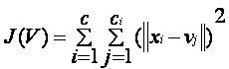

**J(V)**: This represents the objective function or cost function. It is used to measure the total within-cluster variance.

**c**: The number of clusters.

**ci​**: The number of data points in the i-th cluster.

The expression '||xi - vj||' represents the total amount of the difference between xi and vj. The given expression represents the Euclidean distance between xi and vj. Reconsider the distance between each data point and the recently obtained cluster centers.

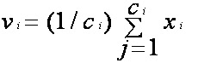

**v(i)​**: The centroid or mean vector of the i-th cluster.

**X(j)​**: The j-th data point within the i-th cluster.

## Random Forest Model

The random forest approach consists of a series of decision trees, whose outcomes are merged into one final result. The random forest classification system has become known for its capacity to provide accurate estimates of the key parameters that are critical in classificationWhen a training dataset with features and labels is sent to a call tree, it will create a set of rules that may be used to make predictions. Each tree within the random forest acquires knowledge based on a randomly selected subset of data points throughout the training process.

When utilizing Random Forests for classification, it is essential to understand that the Gini index is frequently used. The Gini index is an estimation used to figure out how nodes divide on a decision tree.

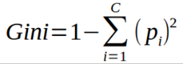

**p(i)**: The probability of picking a data point that belongs to class i.

You can also use entropy to determine how nodes branch in a decision tree.

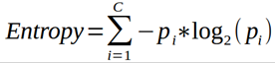

A confusion matrix is a technique used to precisely describe the performance of a classification algorithm. It gives you a more distinct awareness of the positive and negative aspects of your classification model. The event row can be labeled as "positive," whereas the no-event row can be labeled as

A "False Positive (FP)" corresponds to the wrong prediction of event values.

A "True Negative (TN)" is defined as accurately forecasting data that indicate the absence of an event.

A "False Negative (FN)" happens when no-event values are calculated inaccurately.

•A "False Negative (FN)" means instances where no-event values were wrongly predicted.

## SVM Model

Support Vector Machine, or Variational Techniques, refers to a collection of computational approaches used for analyzing information in regression and classification tasks. It gradually displays different groups on a single plane in order to reduce inconsistencies while also being effective in regards to memory consumption. If the error in basic linear regression continues, it confirms its position as one of the most efficient methods to employ. However, when dealing with datasets that are excessively noisy or extremely big, the performance of the algorithm gets harmed because there is a chance of class overlap.

## Linear Regression Model

Linear regression is a supervised machine learning approach that determines the linear correlation between a dependent variable and one or more distinct attributes by fitting a linear equation to observed data. Simple Linear Regression describes a scenario when there is only one independent feature, whereas multiple linear regression refers to a situation where there are several independent features. When there is a single dependent variable, the procedure is referred to as Univariate Linear Regression. Calculate equation for simple linear regression is expressed as follows: y = β₀ + β₁X. However, when there are multiple dependent variables, it is called Multivariate Regression.

The model for a multiple linear regression model is given by y = β₀ + β₁X₁ + β₂X₂ + ... + βₙXₙ.

An efficient approach has been created to speed up the training and prediction of SVM classifiers. This happens through using the cluster centers produced by the k-means clustering process. Random forest algorithm partitions a dataset into K-clusters, where "K" is a value set by the user or selected at random. Linear regression is frequently applied to predict numerical values, making it an efficient approach for such tasks.

# Result

Our proposed strategy involves the use of machine learning to create a system that consists of two primary modules: Analyze agricultural production and provide crop recommendations.

Then used Kaggle dataset in Agriculture accuracy for crop yield predictions. also in this model used Hybrid of K-mean and Linear Regression, Hybrid of K-mean and Random Forest and Support Vector Machine (SVM) algorithm.

In our dataset , there are 8 column and 2200 rows of 22 different Agricultural plants like rice coffee , jute, cotton, maize, etc.

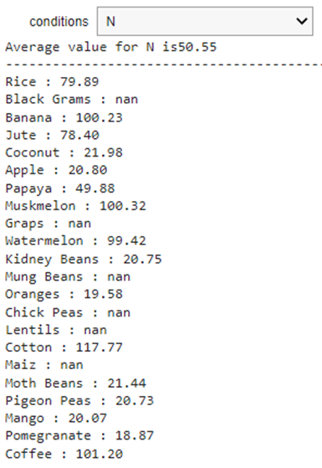

Fig. 1. Average value of Nitrogen

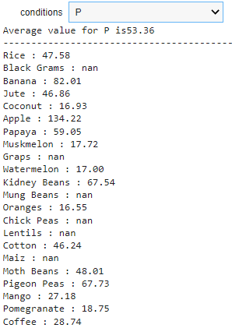

Fig. 2. Average value of Phosphorus

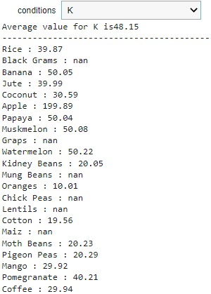

Fig. 3. Average value of Potassium

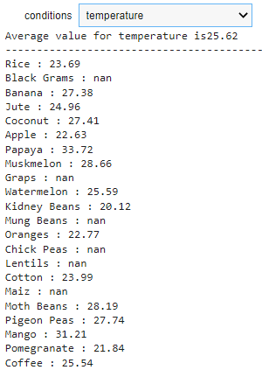

Fig. 4. Average value of Temperature

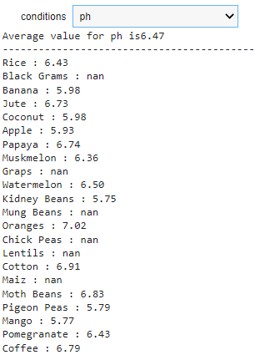

Fig. 5. Average value of pH

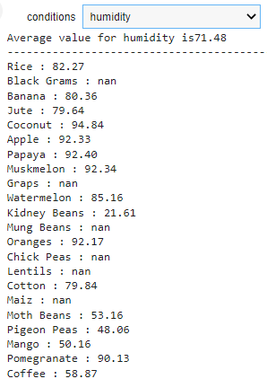

Fig. 6. Average value of Humidity

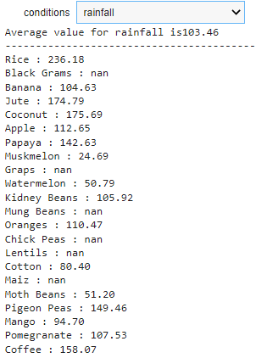

Fig. 7. Average value of Rainfall

The parameters like N P, K, temperature, humidity, PH, and rainfall predict that the most suitable Crop for Given Climatic Conditions is coffee.

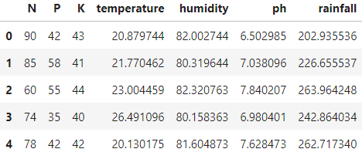

Fig. 8. Dataset of Coffee

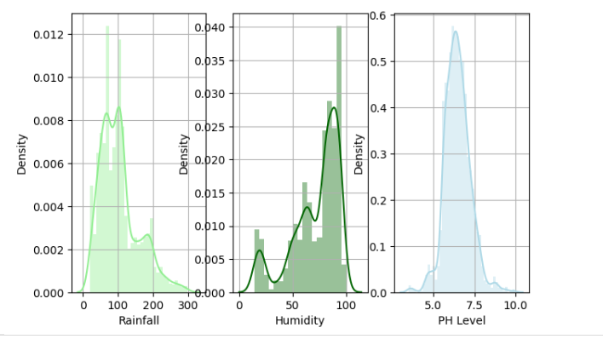

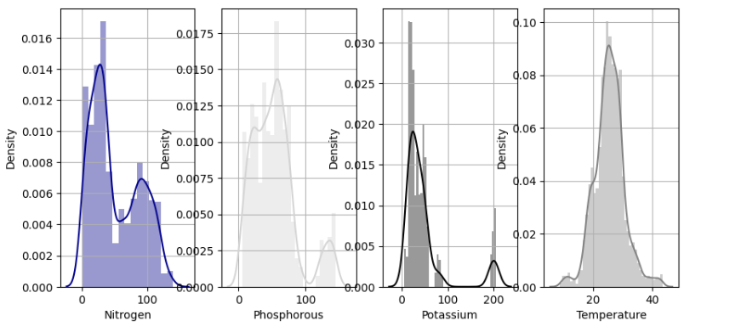

Fig. 9. Density vs Parameters Graph

K-mean algorithm uses Logistic Regression Model for the implementation for predictions. It gives an average 96.82% of accuracy as the result whole dataset.

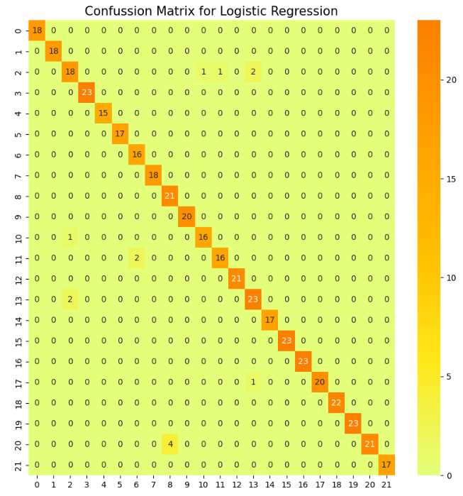

Fig. 10. Confussion Matrix for Logistic Regression

Also , the hybrid of the K-mean and Random Forest is used to predict the crop yield which give the best accuracy of about 99.77% . It also precisely predict coffee as suitable crop for the give parameters or conditions.

Random Forests are computationally efficient due to their ability to train several decision trees in parallel within the forest. Random Forests provide comprehensive model interpretability, but SVMs may be used when interpretability is crucial for your application due to their clear decision boundaries.

Moreover, Random Forests are considered to be more user-friendly compared to Support Vector Machines (SVMs) due to their tendency to necessitate less hyperparameter adjustments.

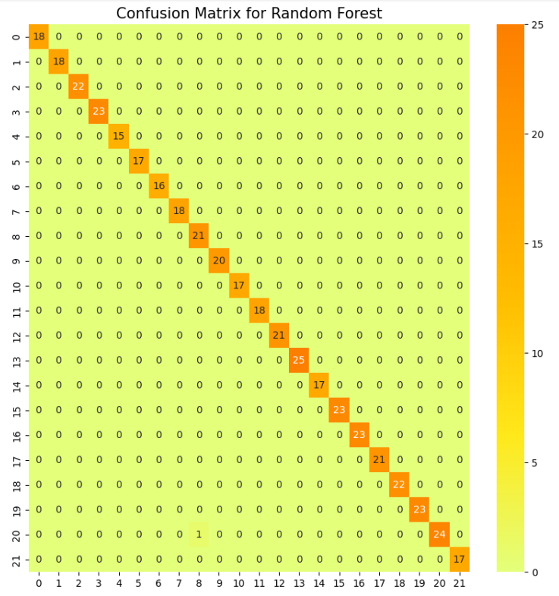

Fig. 11. Confussion Matrix for Random Forest

The confusion matrix indicates that the Random Forest model has strong overall performance, with high accuracy in correctly predicting class labels. Although there are some faults, they are minimal and have a negligible impact on the overall performance.

SVM gives almost of 98.86% of accuracy in prediction.

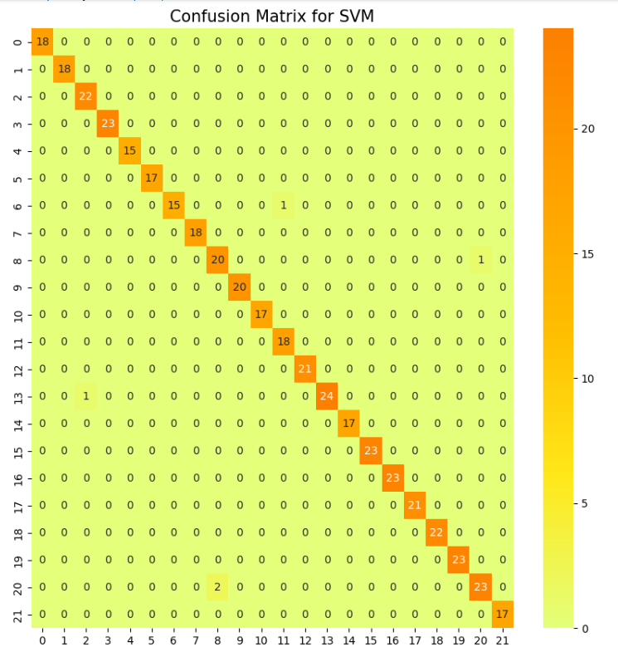

Fig. 12. Confussion Matrix for SVM

The SVM algorithm produces four types of values: positive, negative, true negative, and false negative. The diagonal values consistently display the highest values.

In this picture, the SVM method has the maximum value in terms of F1 score, pH level, NPK level, and many other possibilities.

There is a misclassification between class 3 and class 6. Additionally, class 4 has the lowest classification. Furthermore, class 10 has 20 instances that did not receive a substantial amount.

The SVM model demonstrates precision, accuracy, F1 score, and other performance metrics. It also exhibits resilience. Future enhancements will be discussed in the section on misconceptions. Overall, this approach is effective.

Fig. 13. Accuracy Graph

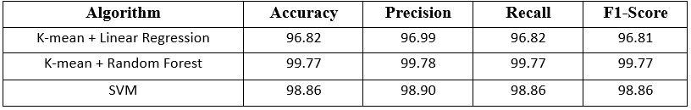

Fig. 14. Accuracy, Precision, Recall and F1-Score

The graph above displays the performance of three distinct machine learning techniques, as measured by their respective accuracy percentages. The K-Mean algorithm attained a precision rate of 96.82%, however the combination of K-Mean and Random Forest surpassed the remaining methods with a precision rate of 99.77%. The Support Vector Machine (SVM) approach demonstrated exceptional performance, with an accuracy rate of 98.86%. The analysis demonstrates that the combination of K-Mean and Random Forest yields the highest level of accuracy, with SVM placing second and K-Mean finishing in third.

To enhance performance, prioritize the optimization of data quality, fine-tuning of hyperparameters, and improvement of feature selection. In addition, utilizing sophisticated models and approaches such as ensemble methods or transfer learning can result in improved outcomes.

# Conclusion

The main aim here is study is to present an overview of current methods for predicting and advising on crop output. This is Subsequently, a depiction of our proprietary model for a system that analyzes and advises on crop production, addressing various agricultural concerns. To focus on the primary elements Regarding our proposed strategy, namely A system for analyzing crops and providing recommendations for agricultural management. we have devised a machine learning system. Agricultural practitioners can employ the suggested approach to aid in determining the optimal selection of crops for cultivation and estimating the corresponding profitability by utilizing yield forecasting. This method is used to acquire extensive knowledge about crops in order to optimize their harvesting process in a highly effective and productive manner in the future.

In order to attain a high level of accuracy in the study, it is crucial to employ a blend of meticulous data collecting, efficient feature engineering, and suitable model selection. By employing cross-validation and regularization approaches, one can enhance the model's generalization and accuracy, hence ensuring a more reliable evaluation.

Among all the algorithms tested, Hybrid of Random Forest and K-Mean emerged as strong models, both of them getting greater accuracy scores compared to the other algorithms utilized. As a result, the crop is recommended based on crucial factors such as temperature, humidity, pH, and rainfall. This research shows the importance of machine learning algorithms in crop prediction and their crucial role in enhancing agricultural practices.

# Future redirection

The future prospects require the change of conventional agriculture into intelligence agriculture, defined by effectiveness, long-term viability, and friendly to the environment through the application of modern technologies. k mean Model and other machine learning techniques can be employed to explore intelligent agriculture practices, from our viewpoint [14].

Enhancing a set of ways of effectively maintaining vegetation, taking into consideration the effect of climate on crop levels and farm activities, to reduce the impact on the environment. The costs associated with agriculture and increasing crop productivity, as well as optimizing profits using online platforms. The research findings need to be repeated in other types of plants found in the region [12].

This would additionally lead to the expansion of the particular dataset. In future endeavours to enhance crop production prediction, it is advisable to analyze and include a crop-specific disease dataset[4]. Including characteristics of the soil in the system is beneficial since considering soil properties is also a significant consideration in identifying which crops to grow. Optimal situations are required for cultivating crops. Weather data can be used to determine the need for additional water[5]. Applying these changes could improve accuracy to a certain extent, as our system can readily accept and integrate them. With the emergence of new technologies, it becomes feasible to improve the system and modify it to suit the preferred setting [7].

**REFERENCES**

1. S. Patel, N. Shinolikar, V. Patkar, and T. P. Singh, “Spatial Decision Support System for Impact Analysis of Soil Characteristics on Crop Production Using Geo-Spatial Technologies,” 2021 IEEE 2nd Int. Conf. Technol. Eng. Manag. Soc. Impact using Mark. Entrep. Talent. TEMSMET 2021, pp. 1–7, 2021, doi: 10.1109/TEMSMET53515.2021.9768754.
2. Y. Shamdasani, “Rural road infrastructure & agricultural production: Evidence from India,” *J. Dev. Econ.*, vol. 152, p. 102686, 2021, doi: 10.1016/j.jdeveco.2021.102686.
3. J. Pant, R. P. Pant, M. Kumar Singh, D. Pratap Singh, and H. Pant, “Analysis of agricultural crop yield prediction using statistical techniques of machine learning,” *Mater. Today Proc.*, vol. 46, no. xxxx, pp. 10922–10926, 2021, doi: 10.1016/j.matpr.2021.01.948.
4. K. Lohitha Reddy and A. P. Siva Kumar, “Machine Learning Techniques for Weather based Crop Yield Prediction,” *Proc. 3rd Int. Conf. Artif. Intell. Smart Energy, ICAIS 2023*, no. Icais, pp. 1263–1268, 2023, doi: 10.1109/ICAIS56108.2023.10073740.
5. N. V. S. Krishna, P. Neeraj, B. Surya, B. V. Prudhvi, and V. H. Deepthi, “Machine Learning Algorithms for Crop Yield Prediction in Real-Time Scenarios,” *ICSPC 2023 - 4th Int. Conf. Signal Process. Commun.*, no. March, pp. 377–381, 2023, doi: 10.1109/ICSPC57692.2023.10126011.
6. S. Mishra and M. Gupta, “Leveraging Artificial Intelligence and Machine Learning for Enhanced Crop Yield: A Crop Recommendation System for Indian Agriculture,” *2023 Int. Conf. IoT, Commun. Autom. Technol. ICICAT 2023*, pp. 1–5, 2023, doi: 10.1109/ICICAT57735.2023.10263734.
7. M. Kandan, G. S. Niharika, M. J. Lakshmi, K. Manikanta, and K. Bhavith, “Implementation of Crop Yield Forecasting System based on Climatic and Agricultural Parameters,” *Proc. - 2021 IEEE Int. Conf. Intell. Syst. Smart Green Technol. ICISSGT 2021*, pp. 207–211, 2021, doi: 10.1109/ICISSGT52025.2021.00051.
8. V. Kumar, M. R. Khan, and R. K. Walia, “Crop Loss Estimations due to Plant-Parasitic Nematodes in Major Crops in India,” *Natl. Acad. Sci. Lett.*, vol. 43, no. 5, pp. 409–412, 2020, doi: 10.1007/s40009-020-00895-2.
9. J. Ranjani, V. K. G. Kalaiselvi, A. Sheela, D. Deepika Sree, and G. Janaki, “Crop Yield Prediction Using Machine Learning Algorithm,” *Proc. 2021 4th Int. Conf. Comput. Commun. Technol. ICCCT 2021*, pp. 611–616, 2021, doi: 10.1109/ICCCT53315.2021.9711853.
10. D. Modi, A. V. Sutagundar, V. Yalavigi, and A. Aravatagimath, “Crop Recommendation Using Machine Learning Algorithm,” *2021 5th Int. Conf. Inf. Syst. Comput. Networks, ISCON 2021*, pp. 1–5, 2021, doi: 10.1109/ISCON52037.2021.9702392.
11. T. K. Mishra, S. K. Mishra, K. J. Sai, B. S. Alekhya, and A. R. Nishith, “Crop Recommendation System using KNN and Random Forest considering Indian Data set,” *Proc. - 2021 19th OITS Int. Conf. Inf. Technol. OCIT 2021*, pp. 308–312, 2021, doi: 10.1109/OCIT53463.2021.00068.
12. R. Kavitha, M. Kavitha, and R. Srinivasan, “Crop Recommendation in Precision Agriculture using Supervised Learning Algorithms,” *2022 3rd Int. Conf. Emerg. Technol. INCET 2022*, pp. 1–4, 2022, doi: 10.1109/INCET54531.2022.9824155.
13. M. S. Teja, T. S. Preetham, L. Sujihelen, Christy, S. Jancy, and M. P. Selvan, “Crop Recommendation and Yield Production using SVM Algorithm,” *Proc. - 2022 6th Int. Conf. Intell. Comput. Control Syst. ICICCS 2022*, no. Iciccs, pp. 1768–1771, 2022, doi: 10.1109/ICICCS53718.2022.9788274.
14. S. Umrao, S. Kumar, H. Gupta, and K. Saxena, “Comparison of Machine Learning Techniques to Estimate Increase in Crop Productivity,” *2023 3rd Int. Conf. Adv. Comput. Innov. Technol. Eng.*, pp. 626–631, 2023, doi: 10.1109/icacite57410.2023.10183134.
15. R. C. Mahore and N. G. Gadge, “A Creative Use of Machine Learning for Crop Prediction and Analysis,” *2022 IEEE Int. Conf. Women Innov. Technol. Entrep. ICWITE 2022 - Proc.*, pp. 1–6, 2022, doi: 10.1109/ICWITE57052.2022.10176256.
16. K. P. Shah, S. N. Sah, K. P. Dharmaraj, and K. Dinesh Kumar, “A Comprehensive Analysis of Machine Learning Algorithms for Suitable Crop Prediction in Agriculture,” *2024 Int. Conf. Cogn. Robot. Intell. Syst. ICC - ROBINS 2024*, pp. 63–68, 2024, doi: 10.1109/ICC-ROBINS60238.2024.10533902.
17. R. Guntukula, “Assessing the impact of climate change on Indian agriculture: Evidence from major crop yields,” *J. Public Aff.*, vol. 20, no. 1, pp. 1–7, 2020, doi: 10.1002/pa.2040.
18. J. Shrestha, S. Subedi, K. Timsina, and M. Kandel, “Conservation agriculture as an approach towards sustainable crop production : A Review,” *Farming Manag.*, vol. 5, no. 1, 2020, doi: 10.31830/2456-8724.2020.002.
19. L. K. Subramaniam and R. Marimuthu, “Crop yield prediction using effective deep learning and dimensionality reduction approaches for Indian regional crops,” *e-Prime - Adv. Electr. Eng. Electron. Energy*, vol. 8, no. June 2023, p. 100611, 2024, doi: 10.1016/j.prime.2024.100611.